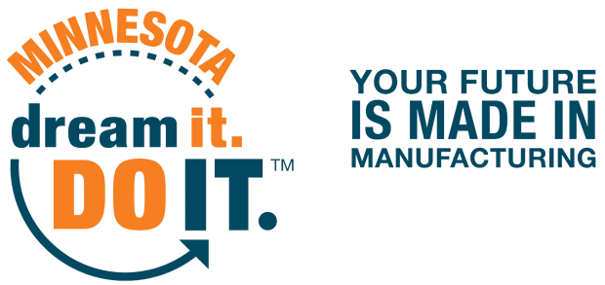
1500 Birchmont Drive NE #34, Bemidji, MN 56601-2699. Phone: (218) 755-2206, dreamitdoitmn.com

RADIO ADVERTISEMENT (SPECIFIC COMPANY)
DREAM IT DO IT MINNESOTA STATEWIDE TOUR OF MANUFACTURING
:30

MANUFACTURING JOBS ARE IN HIGH DEMAND IN MINNESOTA AND MANUFACTURERS WANT TO SHOW YOU WHY.
INSERT COMPANY NAME IS INVITING THE GENERAL PUBLIC FOR TOURS DURING THE DREAM IT DO IT MINNESOTA STATEWIDE TOUR OF MANUFACTURING INSERT DATE(S) AND/OR TIME. GET A FIRSTHAND LOOK AT THE WORLD CLASS MANUFACTURERS IN YOUR OWN BACKYARD!
INSERT COMPANY NAME IS LOCATED AT INSERT ADDRESS

FOR MORE INFORMATION, VISIT TOUROFMANUFACTURINGMN.COM

