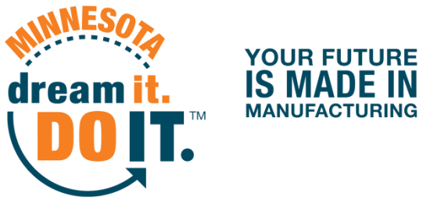
1500 Birchmont Drive NE #34, Bemidji, MN 56601-2699. Phone: (218) 755-2206, dreamitdoitmn.com

DATE

Dear Parent/Guardian,

XXX School has invited your child to participate this October in the Dream It. Do It. Minnesota Statewide Tour of Manufacturing. Dream It. Do It. Minnesota is a program dedicated to sharing the career opportunities in modern manufacturing career opportunities and engaging youth in STEM (science, technology, engineering, and math) events. Advanced manufacturing is fun and a viable career choice!

Through this tour, your child is learning about dynamic and leading edge manufacturing businesses that have seen an explosion of innovative and technological career opportunities in recent years.

We look forward to having your child to participate in this event that showcases innovative and technologically advanced career opportunities in the modern manufacturing market. On DATE(S), these companies are welcoming our students to tour their facilities. ANY OTHER DETAILS ABOUT THE MANUFACTURER(S) AND TOURS IN YOUR AREA.

Overall, we see this as a great opportunity to dispel the common manufacturing myths of a dark and dirty work environment by exposing students to the 21st century world of manufacturing, which includes highly skilled positions and specific postsecondary education beyond the traditional K-12 setting. You can also learn more about today’s manufacturing at the Dream It. Do It. Minnesota website, dreamitdoitmn.com.

If you have further questions about this event or prefer that your son or daughter not participate, please contact XXX at XXX.

Sincerely,

NAME

